Question 1:

Structure the airline travel system by supposing that you travel from Toronto to London by air.

a. Identify and discuss the series of actions you take in a five layered architecture from the start of your journey at Toronto and then five layered actions at the arrival on destination London. [4 Marks]

b. Support your answer by drawing a layered architecture at the starting point of the journey and the destination. Your answer must identify and discuss the action identified both at Toronto and London. [4 Marks]\

1. To go from Toronto to London, there would about 5 sets of action. These would be divided into: Ticketing (purchase and review/complain), Baggage (load and claim), Gates (load and unload), Takeoff/Landing, and Airplane Routing.
   1. At the Toronto airport you:
      1. Purchase your ticket, then
      2. Check in and load your baggage, then
      3. Go to the gate and get loaded onto the plane, after which,
      4. The plane takes off and is then
      5. Routed to its destination (the London airport)
   2. Upon arrival at the airport in London:
      1. Airplane routed
      2. Plane landing
      3. You de-plane at the gate then,
      4. Claim your bags at the baggage claim and,
      5. If you had a bad trip, complain about it to the ticket agent.
2. 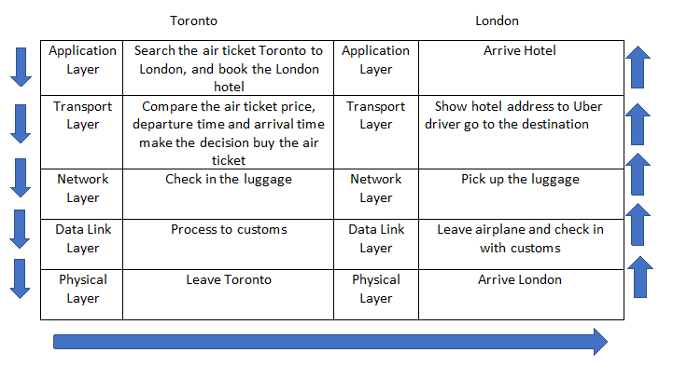The figure gives us a framework that allows us to discuss each airline functionality. When we discuss gate/customs functionality at Toronto for example, we know that it is "below" baggage check in, and "above" runway/takeoff. This also applies at London(passenger offload and baggage claim). Each layer in combination with the layers below it, acts to implement some functionality or service, so to say*.* At the ticketing layer and below, airline-counter-to-airline-counter transfer of a person is accomplished. At the baggage layer and below, baggage-check-to-baggage-claim transfer of a person and bags is accomplished. At the gate layer, departure-gate-to-arrival-gate transfer of a person and bags is accomplished. At the takeoff/landing layer, runway-to-runway transfer of people and their bags is accomplished. Each layer provides its service by (1) performing certain actions within that layer (for example, at the gate layer, loading and unloading people from an airplane) and by (2) using the services of the layer directly below it (for example, in the gate layer, using the runway-to-runway passenger transfer service of the takeoff/landing layer).

Question 2:

Assume that you are accessing a Seneca website from your home computer (desktop/laptop/tablet). a. Identify and discuss the method used at your home to access the Internet and then connection with the Seneca web server. [4 Marks]

b. Sketch/draw a network connection from your device to the Seneca web server. [4 Marks]

1. My computer connects to the internet using a wireless router connection. Using a machine unique address called the IP Address, my computer uses the router in my home to connect to the ISP and gain the needed internet connection. I type the Seneca web address into the address bar of my browser. Using the domain name in the URL, the browser searches the DNS to retrieve the corresponding IP address for the Seneca web server. If it finds a match, the browser then initiates a TCP connection to the server using the three-way handshake which is a process where the client and server exchange synchronize and acknowledge messages to establish a connection. Once the connection is established the browser ends an HTTP GET request (formatted at the application layer of the protocol stack) asking for Seneca’s web page. The web server receives the request and checks for the desired page, then sends the requested page back as a response if it is found. If the server can’t find the requested page, it will send an HTTP 404 error message. The browser then looks for other page elements needed to complete the web page. These usually include images, applets, etc. The static files are cached by the browser so that it doesn’t need to fetch them again the next time the page is visited. For each element needed, the browser makes additional connections and HTTP requests to the server for each element. When the browser has finished loading all images, applets, JavaScript files etc. the page will be completely loaded in the browser window and the Seneca webpage will be appearing on my browser.
2. 